*Document Required for EntityRegistration:

1. **PROOF OF IDENTITY**

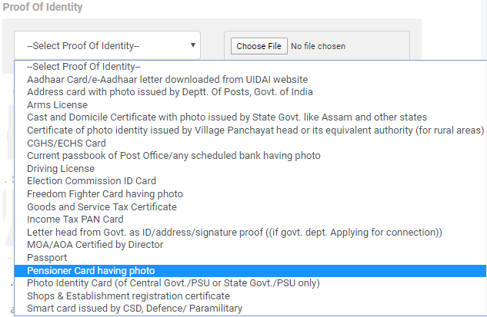

1. **PROOF OFADDRESS**

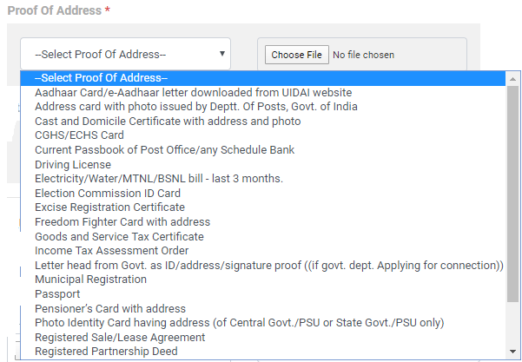

1. **PAN**
2. **AUTHORIZATIONLETTER (Letterhead& SING)**
3. **GST CERTIFCATE**